ExtractEventsForANSLAB: Importing Event Data into ANSLAB

This application is used to create M-file representation of RWNL Events, which can be imported into ANSLAB. Complicating this is the fact that there can be only a single integer to represent the type of Event and any associated independent variables, Group Variables or GVs.

When it is opened, the application displays this window. Click on the “Open RWNL” button to process a new dataset.

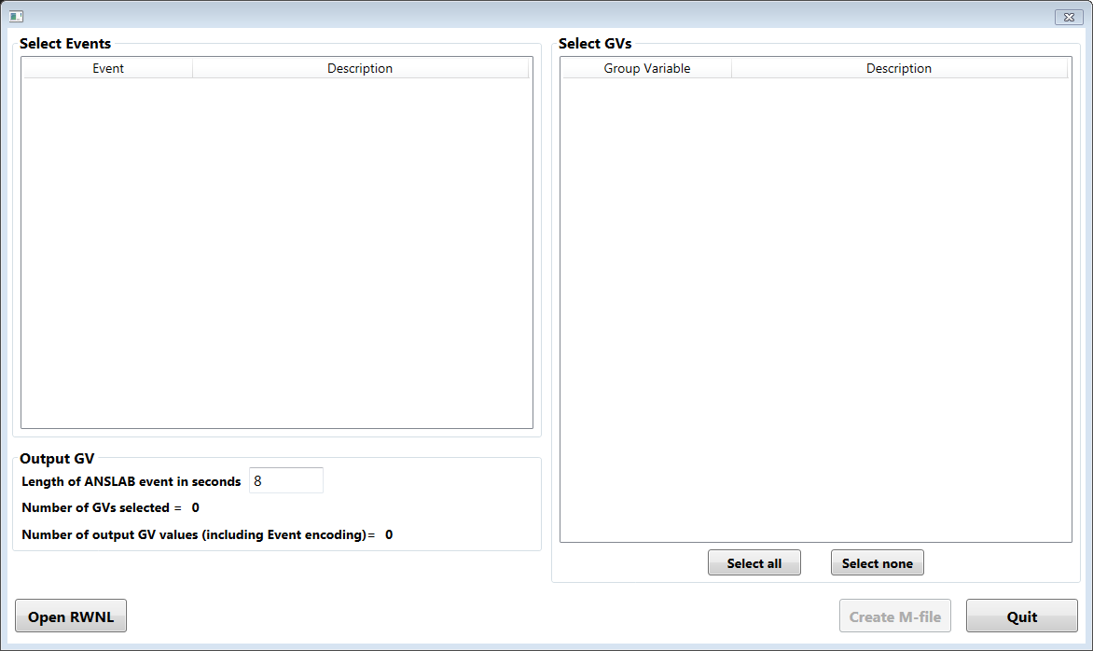

The application opens the corresponding RWNL dataset and displays the Event types that are available in the dataset. Choose one or more of these by clicking on the entries. Also set the length of the epochs as needed.

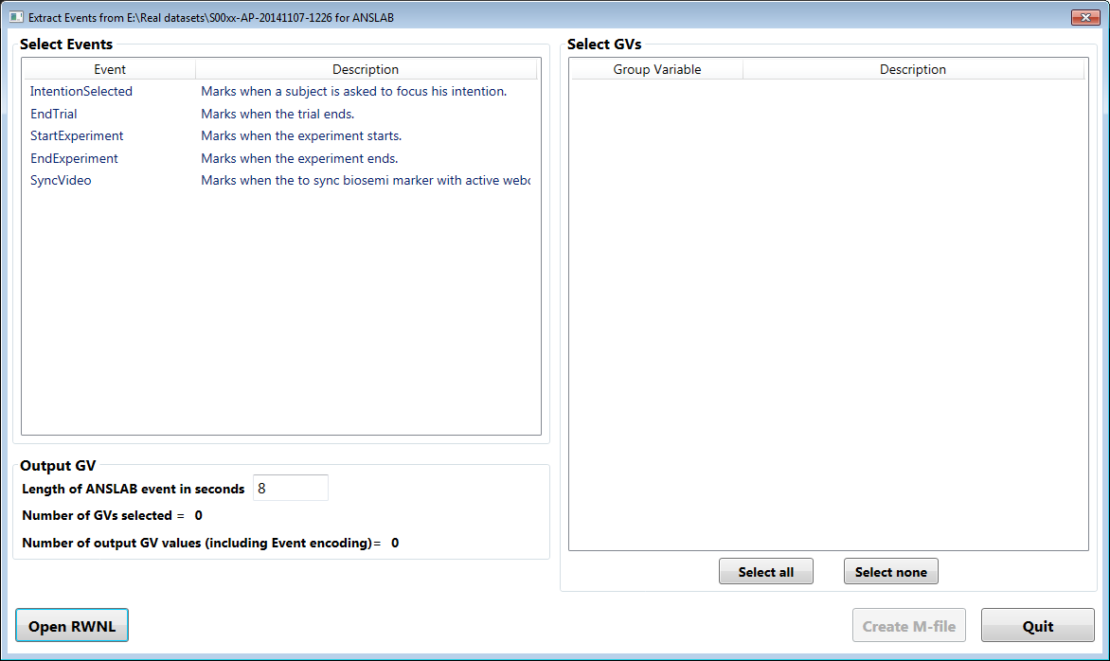

As each Event is selected, the Group Variables (GV) are updated in the box on the right. Each Event has a set of GVs associated with it. If more than one Event is selected, the displayed GVs are the intersection of these sets of GVs. Thus each listed GV will have a value for every selected Event. Here we have selected two Events, which have these 5 GVs in common.

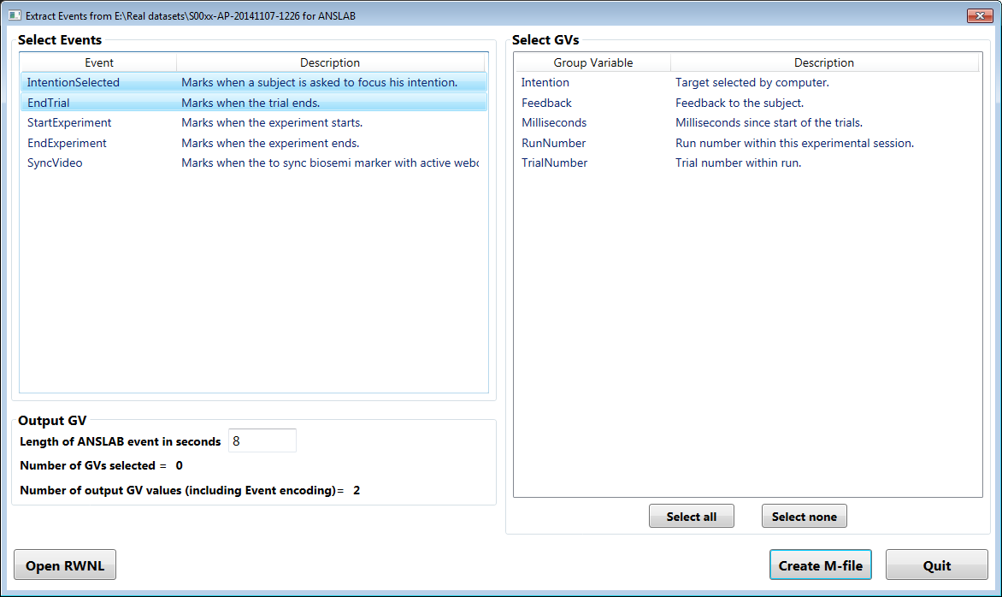

Now we might select two GVs on the right-hand panel. Each of these GVs has a set of values defined by its “dictionary”. The application forms the cross-product of these sets and the set of selected events; then each of these new combinations is assigned an integer value. The number in the left lower box indicates the number of possible output GV values, here indicated as 24. This is the product of the 2 selected Event types, the 4 values that the GV “Intention” can take on, and the 3 values the GV “Feedback” can have (see output shown below which corresponds to this input).

The M-file (named by the dataset name with an extension of “.evt.m”) is created by clicking on the indicated button. In addition to the M-file a log file (with extension “.evt.m.log”) is created indicating the mapping of the assigned number in the output GV to the Event types and GV values of the input dataset (see below).

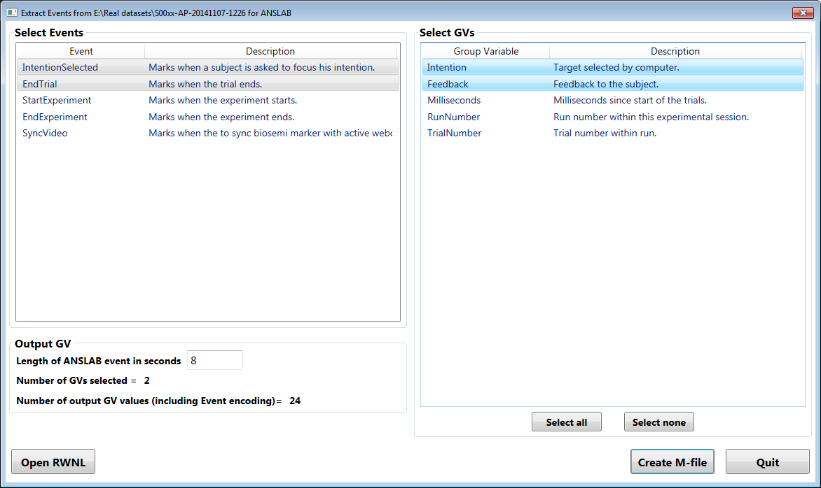

Note that if the user selects a GV that has no dictionary, the program doesn’t know how many possible values may be in the output M-file. This is indicated by a “?” as the indicated number of output GV values. If the user selects more than one GV when one or more of them are without a dictionary, or more than one Event in such a case, the program cannot create an M-file and the “create” button will not be enabled.

Here a single Event has been selected, but with two GVs, one of which (RunNumber) has no value dictionary. Therefore, “Create M-file” is not available until this is corrected.

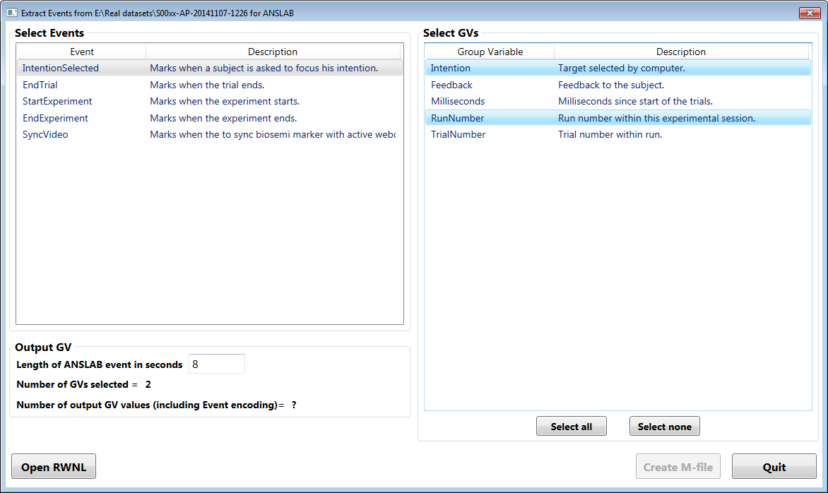

If the user were to select only RunNumber, the button would be enabled, even though the program does not know how many output GV values might be generated. The output GV would uses the direct value of that single input GV. In this case, no log file is created.

The primary output file has an extension of “.evt.m” and can be read by any MATLAB application as an array named T. Each row in T contains the information for a single Event: the assigned output GV value, the time the epoch begins, the time the epoch ends, and the length of the episode. This output is for the case of selection of the two Events “IntentionSelected” and”EndTrial”, and the two GVs (both with dictionaries) “Intention” and “Feedback”.

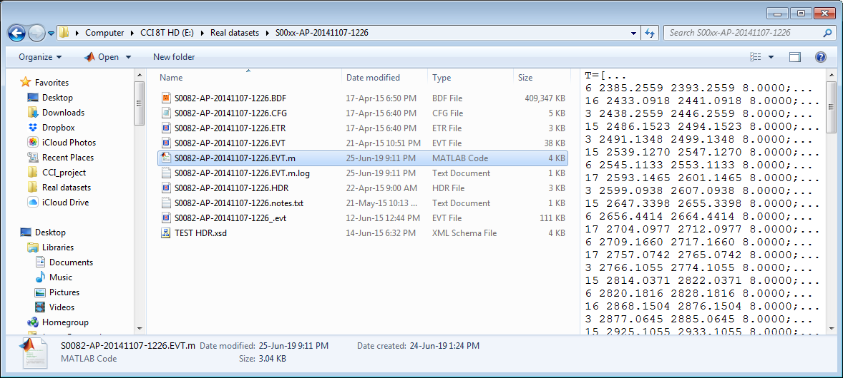

The corresponding log file indicates the mapping of output GV to the Event type and input GV values. Using this map, the value in the first column of the output can be decoded to the Event type and status of the GVs for each episode.

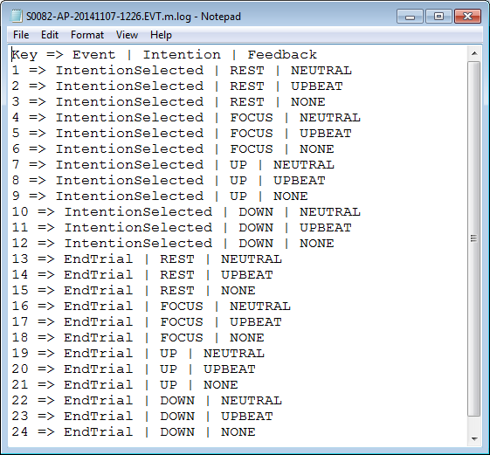

Here is the output for the single Event “IntentionSelected” and GV “Milliseconds” with not dictionary. The first column has the direct value of the input GV. No log file is created.

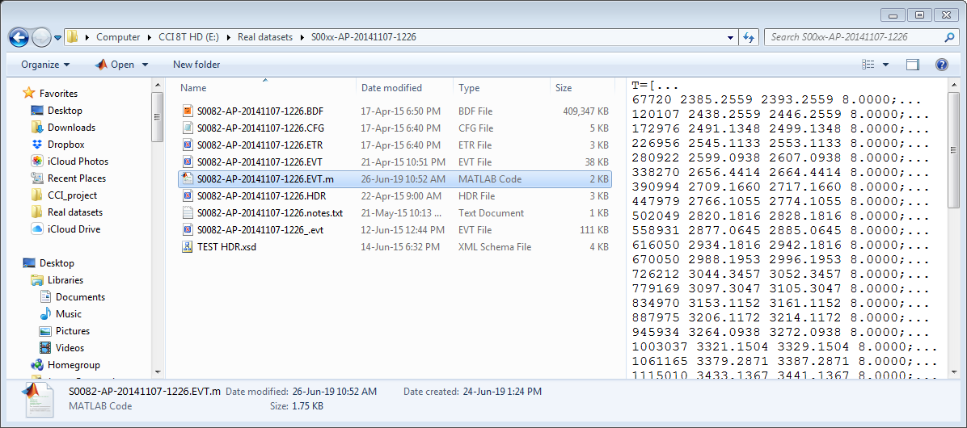

Once the M-file and log file are completed, the display is returned to its initial state and is ready for the selection of another RWNL dataset. Note that because of the automatic naming system, if more than one M-file is to be created for a given dataset, each should be manually renamed before the next is created.